Curriculum Vitae

SANTOSH KUMAR 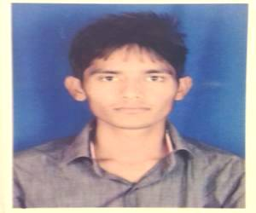

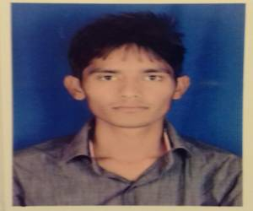

Vill- Mahu Ibrahimpur, Post:-Ghoshla Teh:-hindaun city Distt:-karauli (322254) (Rajasthan) INDIA

Contact no :- 09928460070, 08058-48676 E-mail ID : - santosh.civil2016@gmail.com

CAREER OBJECTIVE

I am seeking a high profile workplace to enhance my abilities and knowledge to maximum & where my Talent & potential is best put in use.I am a team player and prefer an industry offering continued growth. With prospects of innovation & creativity.

PROFESSIONAL STUDIES:
Examination | University/  Board | Institute | Year | Percentage
Polytechnic | B.T.E.R, JODHPUR | Saurabh engg.college Kheda, hindaun city | 2016 | 66.25 %
I
Matriculation | R.B.S.E. | Vishnu Aadarsh Sec.School  Mahu Ibrahimpur | 2012 | 49.33 %

Languages Known: - Basics of computer
Applications MS OFFICE (M.S. word, excel, power point)

EXPERIENCE

- Company : shree balaji imfratech pvt. Ltd.
- Position : assistant engineer (irrigations)
- Period of serving : 6th months
PERSONAL PROFILE

Name SANTOSH KUMAR
Father’s Name Sh. RANGLAL
Date of Birth July,05,1997
Sex Male
Marital Status Single
Languages Known English, Hindi

Extra Curricular Activities:
.
Participated in Cricket, Bad Minton & Caram at college level.

Strength:

Enjoy new challenges, passionate and intellectual hard work.

DECLARATION

I hereby declare that the information furnished above is true to the best of my knowledge and belief ……

DATE (santosh kumar)

